Issue
Subject: Loggers vs. Native Amazonians
Prepared By: Naomi Hill
Date: November 20, 2013
Submitted to: The Brazilian Government, the Brazilian Logging Industry & the Native Amazonians of Brazil
The issue of the fight between the Amazon Loggers and the Native Amazonian Tribes for land in the Amazon rainforest has been a major issue since the 1960’s, when deforestation became an issue (“Geography Alive! Regions” 182). This brief will explore both points of view including the pros, cons, and background necessary to understand the issue. This brief will conclude with a recommendation for the Brazilian Government as well as the Logging industry, and possibly the Native Tribes (although they are choosing to remain un-contacted at the moment) as to who should gain access to the Amazon Rainforest and all of the resources it provides.

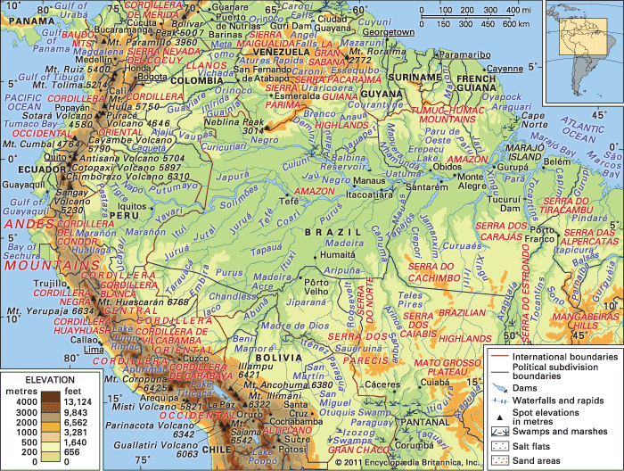
This is an image of South America. The green area represents the Amazon Rainforest. It is about the size of the continental united States.

Background- The Logging Industry
For many years, the logging industry in Brazil has played an important role in Brazil’s economy. It provides wood for Brazil’s paper mills and factories where wooden furniture is made (“Geography Alive! Regions”182). The logging industry also helps out the economic system in Brazil by creating jobs and paying off the national debt (“Geography Alive! Regions”182). As is evident, the logging industry is extremely helpful to Brazil’s economy. However, logging can also have a negative impact on the Amazon Rainforest, and even the world. The Amazon Rainforest produces about 25% of the world’s oxygen, and has been given the name, “the lungs of the earth” because much of the oxygen the world breathes comes from the Amazon Rainforest’s plants. Deforestation is causing the amount of plant life to be reduced, and therefore, the amount of oxygen that is being produced for the human population is decreasing as well.
Pros- The Logging Industry
A major part of Brazil's economic system is its ever-growing logging industry. Providing wood for paper mills, and valuable wood for furniture factories, is just the beginning of all that the logging industry does to help the economy in Brazil (“Geography Alive! Regions”182). Because the logging industry is continuing to grow, and in return is continuing to benefit Brazil's economy, “In 2005, Brazil exported more than $5 billion worth of wood… helping Brazil to pay off its debts to other countries and is improving the living conditions of many of its citizens (“Geography Alive! Regions” 182). Now that the logging industry is growing, more workers are needed. This creates jobs for not only loggers, but also workers in the factories where furniture and paper is made. With more people in the workforce, more families are getting the money they need to lead better lifestyles. In addition to paper and furniture, the rainforest also provides wood for farms, fuel, and charcoal ("Brazil: Natural Resources"). All around, this industry is very helpful to all parts of Brazil's economy.
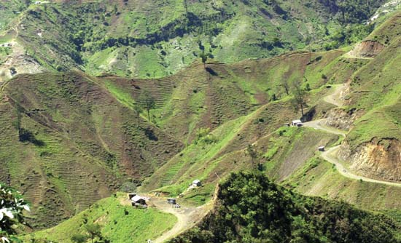
This is an image of land that used to be the Amazon Rainforest, but has been destroyed because of logging

Cons- The Logging Industry
Even though logging industry has brought Brazil out of debt and has provided better lifestyles for its citizens, there are some negatives to this industry that need to be addressed. First off, "Deforestation represents one of the largest issues in global land use in the early 21st century" (Pimm 1). Logging has raised the demand for more and more trees from the rainforest causing the rate of trees being chopped down --or deforestation-- to go up.
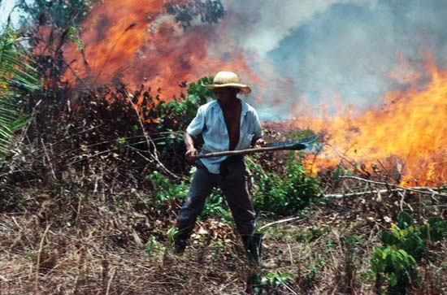
Loggers use different methods for clearing the rainforest. Some loggers chose to set fire to the forest.

Stuart L. Pimm, author of the article "Deforestation", says that, "Given the rate of deforestation most...forests will be cleared within the century" (Pimm 1). Clear cutting is also a major issue that plays a role in deforestation. Instead of cutting down only the trees that they need, loggers with remove all trees from the land. This process completely destroys the forest. If deforestation is causing so much loss in the forest, then some people may believe that it should be controlled or even outlawed. Although loggers play a role in the rate of deforestation, cattle ranchers and farmers also contribute (Pimm 1). In addition, deforestation is also putting the environment at risk and even the human population. The trees in the Amazon Rainforest are an extremely important source of oxygen. These trees not only produce oxygen, they eliminate carbon dioxide in the atmosphere ("Brazil: Natural Resources"). This greenhouse gas may be one of the causes of global warming (Pimm 1).

Background- Native Amazonians
The un-contacted tribes of the Amazon are an extremely interesting group of people. They lead very different lifestyles and have never been exposed to the outside world. They use the land for their everyday survival. Their clothes, food, and medicines come from the environment around them. They use sustainable development--the use of resources in a way which preserves them--to help preserve the many valuable resources of the rainforest for future generations. ("Geography Alive! Regions" 180). They live their life in a way that causes no harm to other people ("Geography Alive! Regions" 180), yet some loggers find them a nuisance so they kill them whenever they are taking up the land that they want for logging purposes.
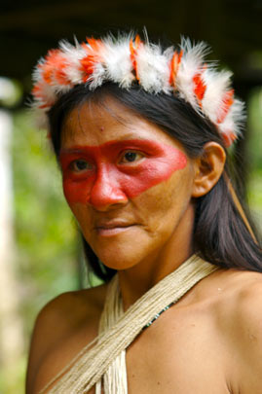
This indigenous woman from a Native Amazonian tribe has her face painted. Many images of different tribes of the Amazon have been seen to have face paint. This may represent social class, or it may have no specific meaning at all.

Pros- Native Amazonians
The native tribes of the Amazon Rainforest calmly live their lives as one with the rainforest. They don't harm it, and continue to preserve it for future generations of their tribe--if their tribe lives to produce future generations. Disease and loggers kill off members or even whole tribes if the natives come in contact with these outside forces of the modern world. Foreign diseases that may be common in the world today--such as the common cold-- could be deadly to natives that haven't come in contact with the bacteria and viruses. According to the Brazilian Constitution, "lands traditionally occupied by Indians are intended for their permanent possession"(Dennis 1).
"lands traditionally occupied by Indians are intended for their permanent possession"

However, loggers and other groups of people who want to use the Amazon Rainforest's resources do not abide by this statement. Traditionally, if land that is wanted by loggers, farmers, and cattle ranchers is home to native Amazon tribes, then those tribes or members of tribes are killed (Dennis 1). Indigenous tribe members that remain constitute a total of less than 25% of Brazil's population (Dennis 1). In addition, they only occupy 12% of the country's total land, and 22% of the rainforest (Dennis 1).

Cons- Native Amazonians
It may be easy to side with the Native Amazonians and think of the loggers as "the bad guys". The natives are a calm and peaceful group of people wanting to live their lives without harming the rainforest in any way. However, loggers want to make money to support their families and their lives, and the logging industry helps the economy. Some people may say that since the native Amazonians aren't doing anything to benefit the economy that it doesn't matter if they are killed off. Others may say that if they aren't doing anything, then why harm an innocent group of people?

Recommendation
There are many pros and cons to both the logging industry of Brazil and the Native Amazonian tribes of the rainforest. Both groups want different things with the many resources that the forest provides. But with tensions rising between the two groups, a decision needs to be made that will benefit the country as a whole, as well as the rainforest as a whole. After analyzing both sides, it is evident that both groups need the rainforest in different ways. The Brazilian Government should set aside land in the rainforest specifically for the native tribes. This way, they can continue their way of life without the dangers of being killed by loggers and diseases. Logging should be allowed to continue, but the logging industry should be careful with the amount of trees they cut down, and only cut down the amount they need to effectively benefit their own lives and the Brazilian economy.

