Subject: Amazon Rainforest
Amazon Rainforest
Prepared by: Kayla Beyer
Date: November 15, 2013
Submitted to: Dr. Izabella Teixeira

The Future of the Amazon

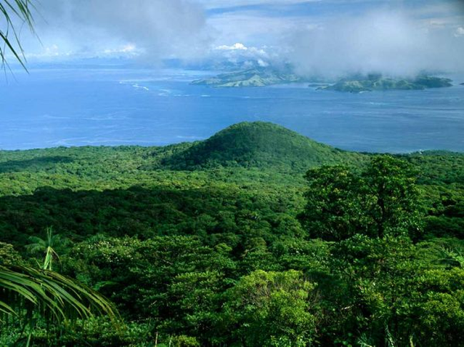
Issue
The biomass of the forest creates habitats for a vast number of animals.
Brazil has experienced issues related to sustainable development in the Amazon Rainforest since the early 1970’s (Brown and Freeman). This complex issue has placed environmentalists and loggers against each other for many years. There are benefits and drawbacks of each side which will be discussed in detail to determine whether the loggers or environmentalists should be given access to the rainforest.

Background
The Amazon Rainforest is home to approximately one million indigenous people whose families have called the rainforest home for thousands of years (Hollander 30-31). The Brazilian government has encouraged people to log, farm, and mine in this forest to help the Brazilian economy succeed throughout history (Hollander 30-31). Inevitably, these activities have resulted in the Amazon Rainforest, the “lungs of the Earth”, being destroyed (Brown and Freeman). If these activities continue, humans will not be able to survive on this planet, but if these activities do stop, people will become homeless. Brazil’s government and its people need to address this issue immediately and should feel a sense of urgency when deciding what the future of the Amazon holds.

Benefits of the Logging Industry
Although it may be easier to side with the environmentalists, logging does positively impact the economy. According to Charlie Cray, the Brazilian government put a mahogany ban upon virtually the entire logging industry in December of 2001 (Cray 6). This ban was put into place in order to shut down all illegal mahogany operations as mahogany is a precious species of wood selling for over 1,600 dollars per cubic meter (Cray 6). This objective was achieved, but many legal logging companies also suffered. Consequently, companies had to lay off workers which means the economy is suffering along with the people. These people were not able to support their families, and they may have had to rely on government aid which takes money away from other governmental operations. This example exemplifies how important logging is to the Brazilian economy.

Downfalls of the Logging Industry and Positives of Environmentalists
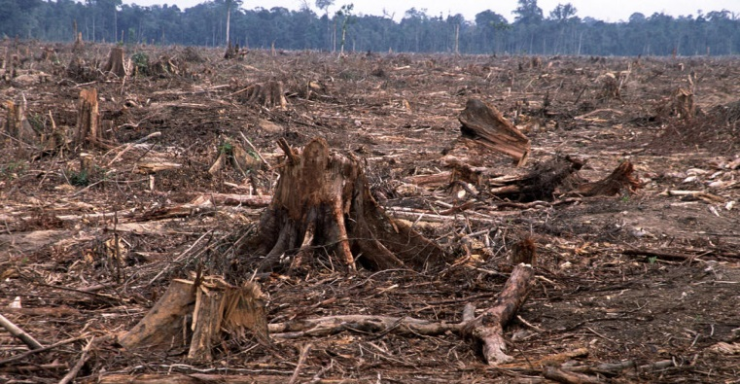
On the other hand, logging can cause serious harm to the forest and the indigenous people within it. The main issue with logging is deforestation which has global consequences (“Deforestation”). Forests hold carbon in the form of wood and other biomass as trees grow which clearly takes carbon dioxide out of the atmosphere (“Deforestation”). Later, the rainforest is burned and carbon dioxide, a greenhouse gas, can potentially alter global climate as the trees that were burned can no longer seize the carbon (“Deforestation”). The destruction of the Amazon Rainforest happens to be one of the top contributors to global warming (“Deforestation”). This emphasizes that political leaders as well as citizens of all countries need to come together to decide what needs to be done as these statistics are extremely alarming. Since the large scale development of the Amazon Rainforest began in the late 1960’s, approximately 15 percent of the forest has been lost (“Preserving Amazonia: Key”). Based on a World Wildlife Fund report released in March 2009, if that number doubles, the impact on global climate will be permanent (“Preserving Amazonia: Key”). There is not much time left. It took us roughly 40 years to get to 15 percent, and the logging industry is developing the rainforest at a faster rate now. This is a major issue since it is going to negatively impact future generations. Research conducted by an international team of microbiologists states that deforestation can cause a loss in the diversity among the microbial organisms responsible for a functioning ecosystem (“Deforestation in the”). We may lose even more species than what is killed by deforestation because organisms will not be able to function if their neighbors have been killed by loggers. As a result, our ecosystem will not survive.
Deforestation completely destroys the forest.

Drawbacks of Environmentalists
Although protecting the rainforest is generally a benefit to the environment as well as the indigenous people, it can cause serious harm to the people within it. At dawn on June 5th, 2009, police and soldiers came down to the Amazon rainforest to clear a blockade set up by about 3,000 Awajun and Wampis Indians and coordinated by an environmental group concerned about the future Amazonia will hold (Dudenhoefer 22). These Indians and environmentalists were protesting to demand the repeal of nine laws that threatened Indian land rights (Dudenhoefer 22). The police came into the forest in armored vehicles, assault rifles, and helicopters to “break it up” (Dudenhoefer 22). The indigenous people only had wooden spears (Dudenhoefer 22). In the end, over 200 people were injured, along with 11 protesters and 13 police officers who died (Dudenhoefer 22). Using this data, it is clear that environmentalists will not compromise for the greater good of all people. This personality type that environmentalists possess makes opposing viewpoints not want to compromise with them either which leads to a more complex issue that no politicians want to deal with.

Recommendation
Important Trends and Developments
- Logging is essential to the Brazilian economy
- 15% of the rainforest has been lost since the late 1960’s
- Approximately 25% of the Earth’s oxygen comes from the Amazon Rainforest
- Environmentalists have strong opinions

In the end, it needs to be decided who will have access to the Amazon Rainforest. There are advantages and downfalls of both perspectives, but the rainforest has to be developed sustainably. Otherwise, future generations will not be able to enjoy the natural beauty of the rainforest or even survive for that matter. If more plants die, then they clearly will not be able to seize carbon and turn it into oxygen for humans to breathe on this planet (“Deforestation”). Parents today want their great grandchildren to be able to survive and live life to the fullest. Because logging greatly benefits the economy, it cannot end. Instead, illegal logging needs to end without disrupting the operations of legal logging companies. This way, logging will develop the forest sustainably without negatively impacting the economy of Brazil. Next, environmentalists should be given areas of the forest that they can preserve. If illegal logging ends and environmentalists are given areas they can preserve, the issue of the Amazon Rainforest will soon be controlled.

Works Cited
"Brazil Sends More Environmental Inspectors To The Amazon Rainforest." Canadian Press, The (n.d.): Newspaper Source Plus. Web. 7 Nov. 2013.
Brown, Bryan, and Freeman, Suzanne. "Saving the Amazon: Brazil Has Become an Economic Powerhouse. What Does That Mean for the Amazon, a Precious Resource for the Entire World?" Junior Scholastic 23 Apr. 2012: 10. General OneFile. Web. 9 Nov. 2013.
Cray, Charlie. "Mahogany Buyers Stumped. (The Front)." Multinational Monitor 22.12 (2001): 6. General OneFile. Web. 7 Nov. 2013.
"Deforestation." Britannica School. Encyclopedia Britannica, Inc., 2013. Web. 14 Nov. 2013. .
"Deforestation in the Amazon Equals Net Losses of Diversity for Microbial Communities." Space Daily 1 Jan. 2013: n. pag. General OneFile. Web. 7 Nov. 2013.
"Deforestation." WorldWildlife.org. World Wildlife Fund, n.d. Web. 16 Nov. 2013.
Dudenhoefer, David. "VISION QUEST: Who Will Control The Future Of The Amazon?." World Watch 22.6 (2009): 22. Science Reference Center. Web. 8 Nov. 2013.
Hollander, Malika. "The Vanishing Amazon." Brazil: The Land (2003): 30-31. History Reference Center. Web. 8 Nov. 2013.
Moran, Dennis. "Interests Collide in the Amazon Basin." World Geography: Understanding a Changing World. ABC-CLIO, 2000. Web. 7 Nov. 2013.
"Preserving Amazonia: Key Question." World Geography: Understanding a Changing World. ABC-CLIO, 2000. Web. 9 Nov. 2013.
"Rain Forest." National Geographic. N.p., n.d. Web. 16 Nov. 2013.

