Twitter, Facebook Become Vital During Japan Earthquake
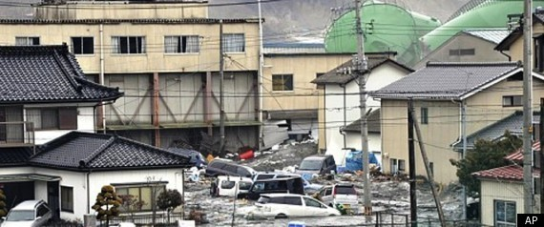

The 8.9 magnitude earthquake and subsequent tsunami that shook Japan early Friday morning left more than a thousand killed and many more missing. Waves demolished buildings and transportation systems, caused electrical blackouts, and left telephone networks congested, cutting off communication between loved ones and family members. However, with the countless updates posted on Facebook and Twitter one message was clear: Japan, you are not alone.
1

Through the use of social networking sites such as Twitter, Facebook, and Mixi, people all around the world were able to get instant updates on the statuses of friends and family, as well as send thoughts and prayers to those in need. A trend of Twitter hashtags such as: #prayforjapan, #japan, #japanquake and #tsunami began appearing on most social networking and microblogging sites -- some of which received thousands of tweets per second, according to Poytner.org.
2

"While there are so many technologies at this time that isolate us from our fellow beings, social networking tools have shown their ability once again to unify us as human beings, and to bring out what is most altruistic and empathetic in our natures,"said Brad Shimmin, an analyst at Current Analysis.
3
Those involved in relief efforts also took to Twitter, posting information about everything from emergency phone lines for non-Japanese speakers to tsunami alerts, altered train schedules and lists of shelters for those left homeless, reports computerworld.com.
4

Kotaku.com reports CyberConnect's Hiroshi Matsuyama even used Twitter to open up his studio to strangers in need. Matsuyama said he has enough space for about 30 people and offered his beverages, food and television. "From what I've seen today, social networks have brought out the best in people, not only encouraging them to take action but also supporting them in those efforts to bring relief to the victims of this catastrophe," Shimmin added.
5

This isn't the only time social networking sites have been used during times of disaster. Twitter and Facebook were also lifelines during massive earthquakes in Chile and Haiti last year.
6

MLA Citation:

“Twitter, Facebook become vital during Japan earthquake.” The Huffington Post. 25 May 2011. Web.

