Using the Power of Social Media
By: Kimberly Beller
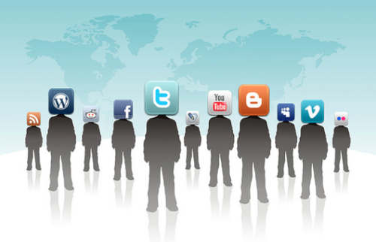
Social media has changed the world as we know it. Since the dawn of the first internet service in 1969, the power of the internet has grown into what we now call the Social Media Age. The magic of social media has changed the way the world has developed. Since the first email in 1971 to the first bulletin board sites developed on major Universities nation wide, social media has far surpassed expectations all over the globe. The power of social media is so widespread that more controlled nations hold tight constraints on its use. Nations like China and Iran ban certain sites and have massive control over the use of other methods of social networking.
1

When America Online hit the scene in 1985, fewer than 1 percent of homes had a computer. By the early 1990s, an almost instantaneous trend began. In a few short years, the numbers rose to over 51 percent, beginning an age of information that has changed the world. Reaching nearly one in four people all over the world, today there are over 2 billion people on over 300 social network sites worldwide. When Mark Zuckerberg developed Facebook in 2004, he had no idea it would go beyond the walls of Harvard where the site was used strictly for networking within the university. In 10 short years, it has completely powered over all of its possible competitors and is used by corporations worldwide. The general thought is social media is a mandatory need in day-to-day business operations. Some consumers refuse to patronize businesses without a social media presence.
2

Some say that social networking has brought better understanding of other cultures and is in some ways the cause of social understanding for everything from human suffering in lower developed societies to the social change we see today. Today the power of social media has been used in both positive and negative ways. We have all heard the horror stories of teens being harassed in school spilling over into their personal life online. But the positive opportunities have far outweighed the negative. Through sites like Facebook and Twitter, families have been reunited and lives have been saved. Utilizing page creation through Facebook, people have developed sites for those who wish to become organ donors and can register and leave details for hospitals such as Johns Hopkins, and the Texas Medical Center in hopes of saving more lives. Using the power of social media, social causes have been created that would have otherwise never left the ground, turning the making of millionaires under the age of 30 a fast growing trend.
3

Social media has even used its power to bring closure to stories other arenas of media were never able to accomplish. In 1987, a terrified young girl left her hours old newborn in a bathroom in an Allentown Burger King. Known for nearly three decades as the “Burger King Baby,” Katheryn Deprill took to Facebook to find her birth mom. She simply posted a picture of herself holding a sign explaining who she was and what she was trying to accomplish, to find the mom that abandoned her 27 years ago. In less than a month, she had been reunited with her birth mom after her post was shared over 600,000 times. Using the power of social media can have consequences, but it can also do a lot to make society better if it is used for the greater good.
4

MLA Citation:

Beller, Kimberly. “Using the power of social media.” Liberty Voice. 27 March 2014. Web.

